**Converting HTML to PDF using Blink in AWS Elastic Beanstalk**

The Syncfusion® [HTML to PDF converter](https://www.syncfusion.com/pdf-framework/net/html-to-pdf) enables reliable transformation of HTML webpages into PDF documents using the Blink rendering engine within AWS Elastic Beanstalk. This guide outlines a step-by-step approach to perform accurate and seamless conversions in the AWS environment while preserving the original layout and design of the HTML content.

**Steps to convert HTML to PDF using Blink in AWS Elastic Beanstalk**

**1.Create an ASP.NET Core MVC Application**: Initiate a project using ASP.NET Core Model-View-Controller pattern.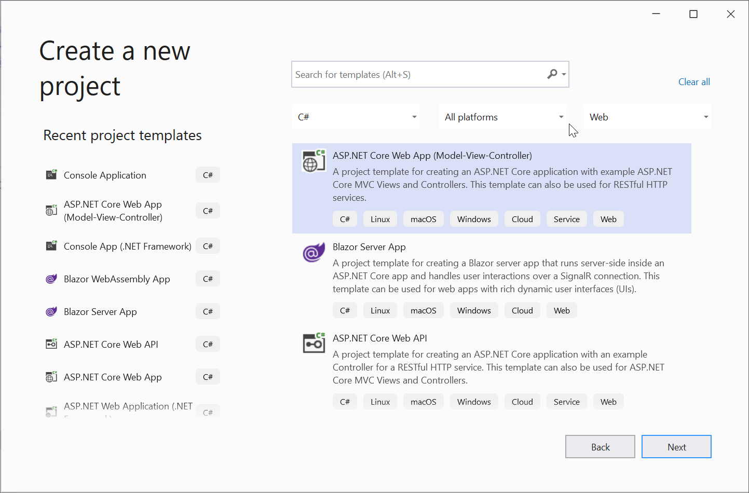

**2.** **Configure Your Project:** On the configuration page, provide a project name and proceed by selecting Next.

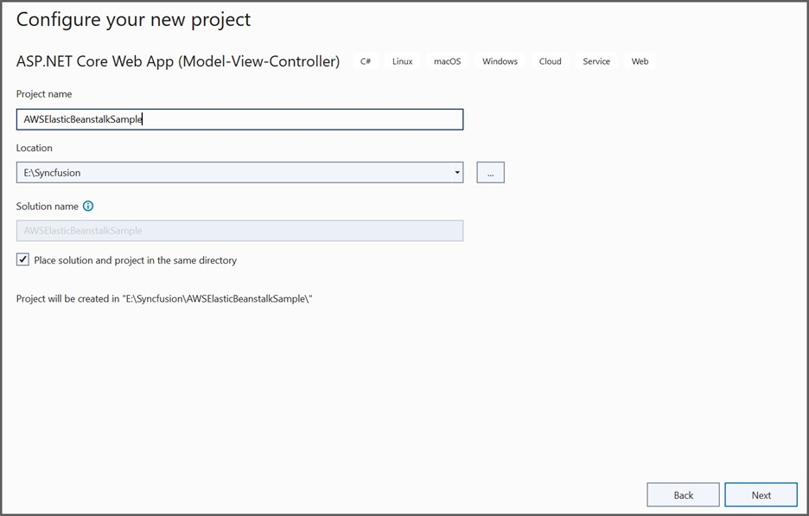

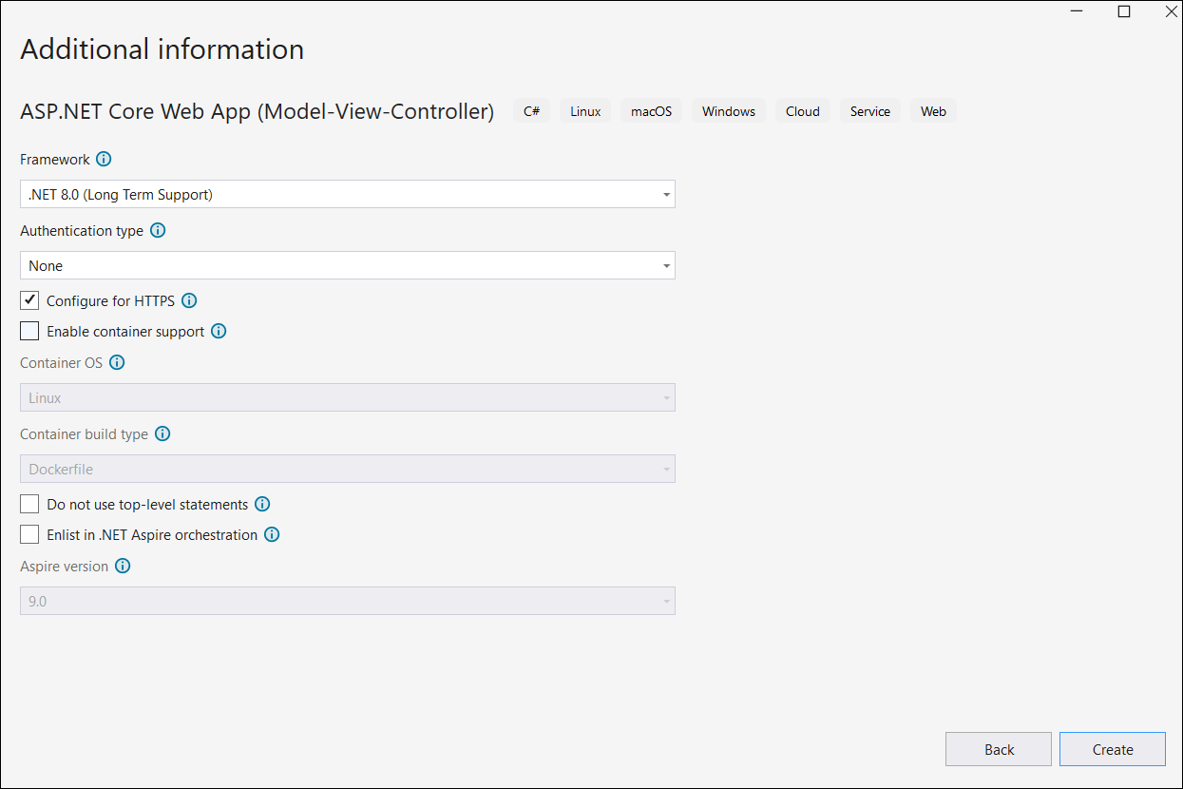

**3.Install Required Packages**: Add the [Syncfusion.HtmlToPdfConverter.Net.Aws](https://www.nuget.org/packages/Syncfusion.HtmlToPdfConverter.Net.Aws/) NuGet package to your project.

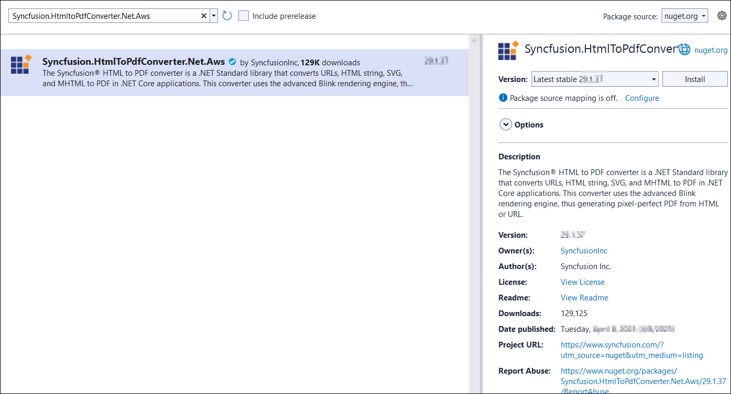

**4.** Set Up Your Controller: In the HomeController.cs, include the necessary namespaces.

|  |
| --- |
| **using** Syncfusion.Pdf;  **using** Syncfusion.HtmlConverter;  **using** System.IO; |

**5.** **Create a Button for Conversion:** Add a button in **index.cshtml** to trigger the conversion

|  |
| --- |
| @{  Html.BeginForm("BlinkToPDF", "Home", FormMethod.Get);  {  <div>  <input type="submit" value="HTML To PDF" style="width:150px;height:27px" />  <br />  <div class="text-danger">  @ViewBag.Message  </div>  </div>  }  Html.EndForm();  } |

**6.** **Implement the Conversion Logic:** In HomeController.cs, define an action method BlinkToPDF.

|  |
| --- |
| public IActionResult BlinkToPDF()  {  // Initialize HTML to PDF converter with Blink engine  HtmlToPdfConverter htmlConverter = new HtmlToPdfConverter(HtmlRenderingEngine.Blink);  BlinkConverterSettings settings = new BlinkConverterSettings();  // Disable sandboxing  settings.CommandLineArguments.Add("--no-sandbox");  settings.CommandLineArguments.Add("--disable-setuid-sandbox");  // Set viewport size  settings.ViewPortSize = new Syncfusion.Drawing.Size(1280, 0);  // Apply settings to converter  htmlConverter.ConverterSettings = settings;  // Convert HTML to PDF  PdfDocument document = htmlConverter.Convert("https://www.syncfusion.com");  // Save document to memory stream  MemoryStream stream = new MemoryStream();  document.Save(stream);  // Return PDF file  return File(stream.ToArray(), System.Net.Mime.MediaTypeNames.Application.Pdf, "BlinkLinuxDockerAWSBeanstalk.pdf");  } |

**7.** **Publish to AWS Elastic Beanstalk:** Right-click the project and select Publish to AWS Elastic Beanstalk (Legacy).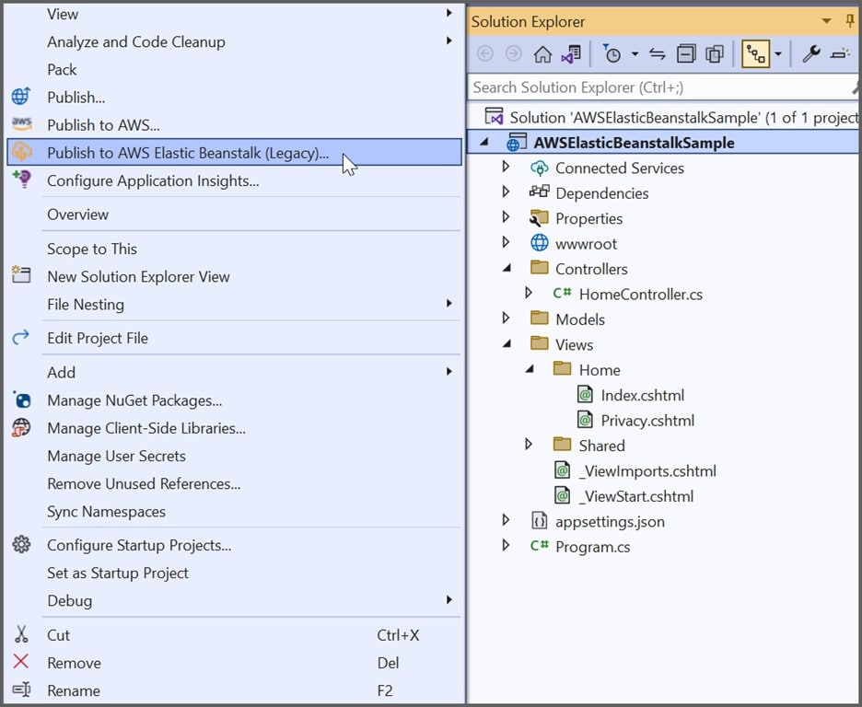

**8.** Choose **Create a new application environment** and proceed by clicking Next.

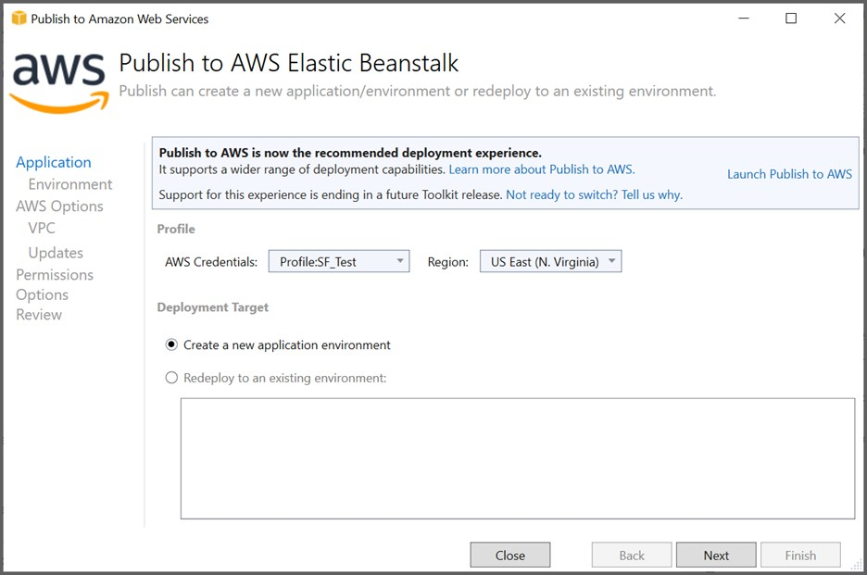

**9.** **Configure AWS Environment:** Provide a name for the environment and URL, ensuring availability through the Check availability option.

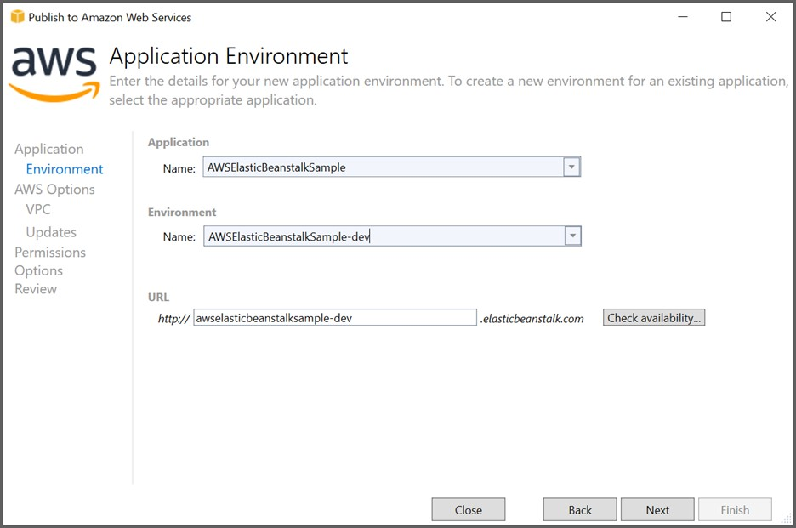

**10.** Select **t3a.micro** as the instance type and proceed through the remaining configuration steps.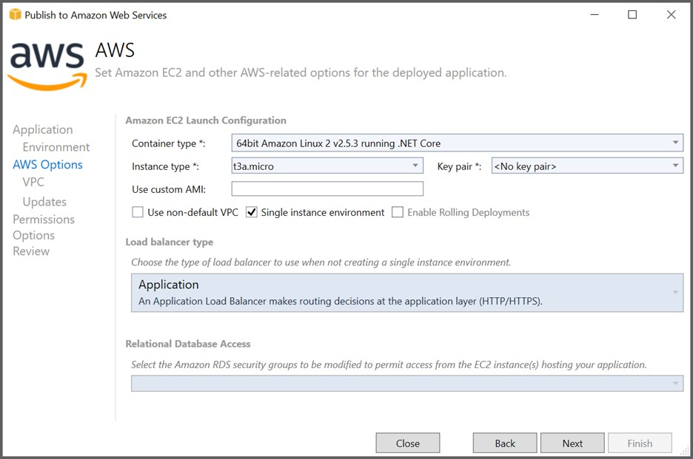

**11.**Select the Roles and **Next** option from the Permissions window.

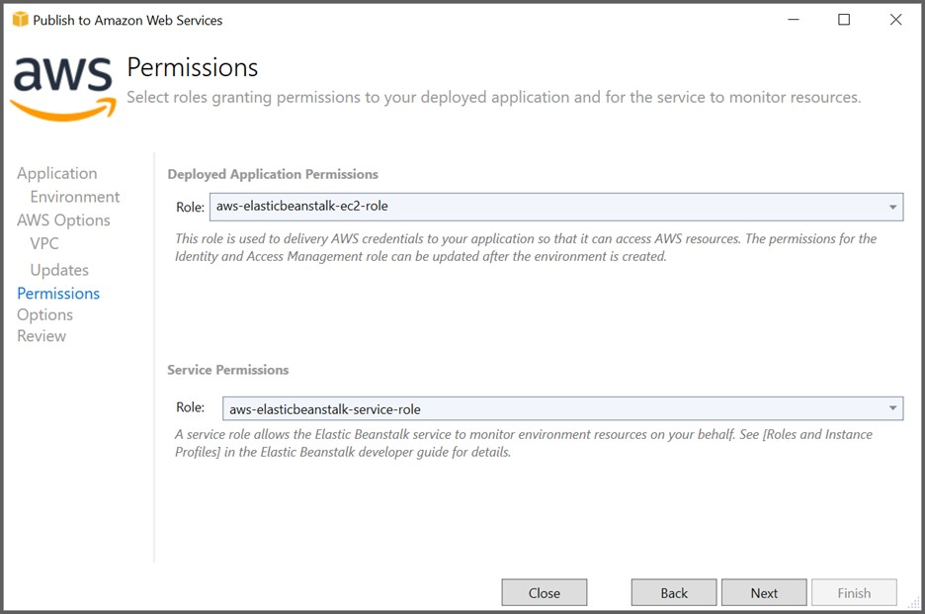

**12.**Click **Next** from the Application Options window.

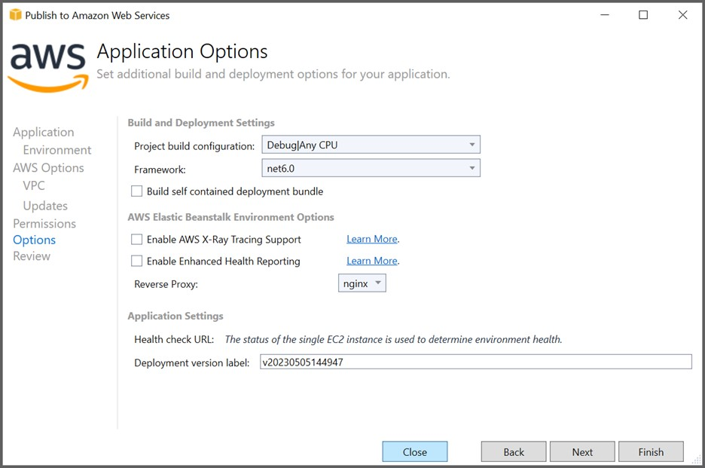

**13.**Click **Deploy** from the Review window.

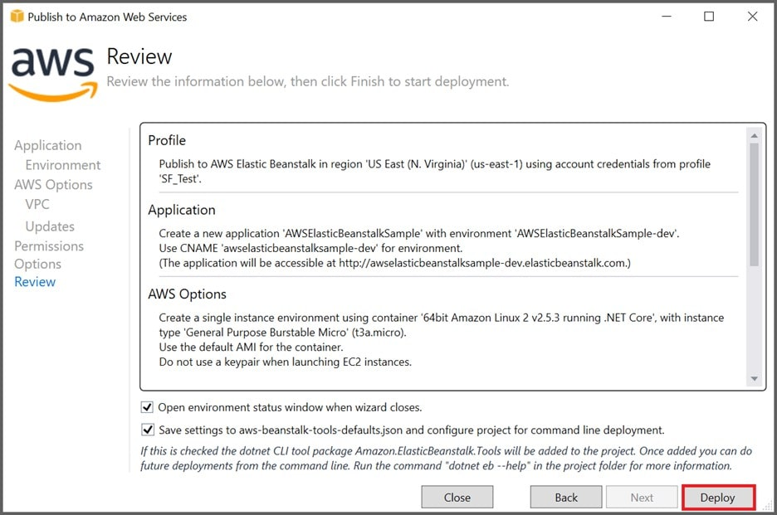

**14.**Click the **URL link** to launch the application once the Environment is updated successfully and Environment status is healthy.

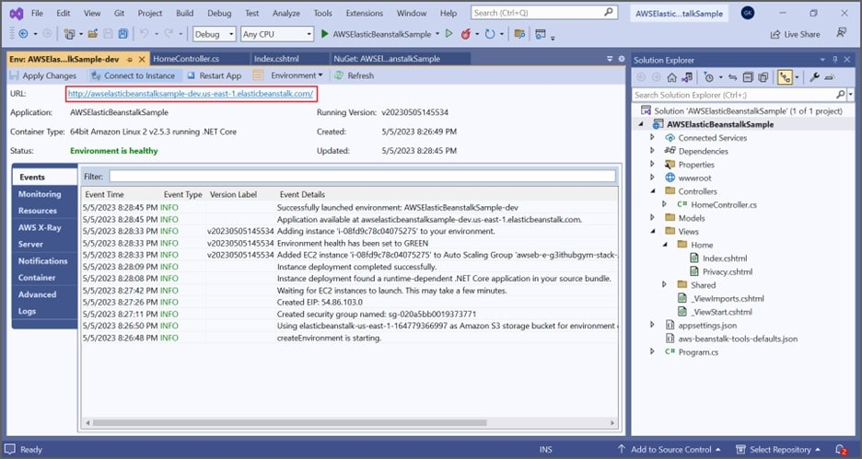

Now, the webpage will open in the browser. Click the button to convert the webpage to a PDF document.

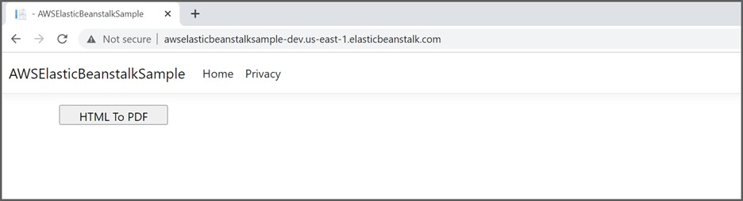

By executing the program, the output PDF document will be generated as shown below.

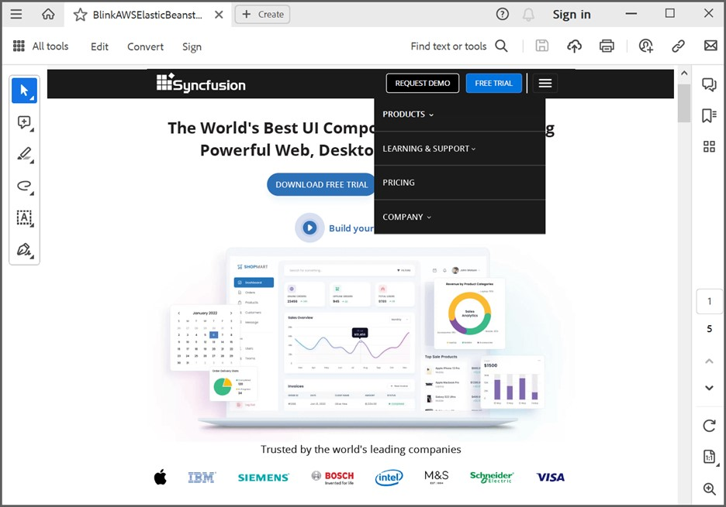

A complete working sample for converting an HTML to PDF using Blink in AWS Elastic Beanstalk can be downloaded from [**GitHub**](https://github.com/SyncfusionExamples/html-to-pdf-csharp-examples/tree/master/AWS/AWSElasticBeanstal).

Take a moment to peruse the documentation for [converting HTML to PDF](https://help.syncfusion.com/file-formats/pdf/converting-html-to-pdf), where you'll find various options, such as converting a URL to PDF, HTML string to PDF, and handling hyperlinks.

**Conclusion**

I hope you enjoyed learning about how to convert HTML to PDF using Blink in AWS Elastic Beanstalk.

You can refer to our [**ASP.NET Core PDF’s feature tour**](https://www.syncfusion.com/document-processing/pdf-framework/net-core) page to know about its other groundbreaking feature representations. You can also explore our [**ASP.NET Core PDF example**](https://ej2.syncfusion.com/aspnetcore/PDF/Default#/material) to understand how to present and manipulate data.

For current customers, you can check out our [**ASP.NET**](http://asp.net/) Core components from the [**License and Downloads**](https://www.syncfusion.com/account/downloads) page. If you are new to Syncfusion®, you can try our 30-day [**free trial**](https://www.syncfusion.com/downloads/aspnetcore-js2) to check out our [**ASP.NET**](http://asp.net/) Core PDF and other [**ASP.NET**](http://asp.net/) Core components.

If you have any queries or require clarifications, please let us know in comments below. You can also contact us through our [**support forums**](https://www.syncfusion.com/forums), [**Direct-Trac**](https://www.syncfusion.com/support/directtrac/incidents/), or [**feedback portal**](https://www.syncfusion.com/feedback/aspnet-core?control=pdf). We are always happy to assist you!